Updated March 2017

Registration Quick Reference Card for Employees/Associates

Contents
Registration 2
Activate Your Email Address 7
Activate Your Mobile Phone 7
Forgot Your User ID/Password? 8

Disclaimers:
- Employee registration does not apply to admin-only services such as General Ledger Interface, ADP Reporting, and Payroll QuickView.
- The registration process outlined in this document does not apply to RUN Powered By ADP® Employee Access®.
- The registration process will vary slightly for employees registering for ADP Retirement Services on the participant website at www.mykplan.com.

Registration
Welcome! ADP is committed to protecting your privacy and ensuring that only you can access your personal information. To assist us in meeting that commitment, you must register with us before using our services.
Before You Begin: You will need your registration code and the URL to access your ADP service login page.
- ADP service login page: https://workforcenow.adp.com/public/index.htm
- Registration code: NCAPHA1-payroll

Security Tip: To protect your personal information from fraud, be sure to use a known computer or mobile device with a trusted internet connection.
On the login page of your ADP service, click the link to register and create your ADP service account. Follow the instructions on the page.
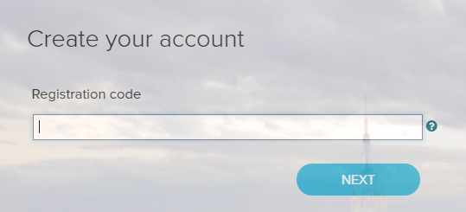
Enter your personal registration code or your organizational registration code.
NCAPHA1-payroll
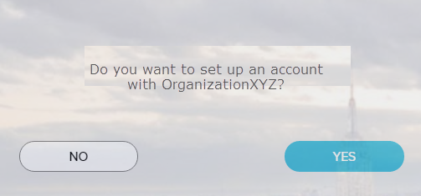
If you do not recognize the name of your organization, select No and start over.

Enter your identity information.
Option 1  If you entered an Organizational Registration code, the information requested might vary based on your organization’s setup.  You will be asked to enter your SSN and your birth date.  Google™ reCAPTCHA challenge:  Click on the “I’m not a robot” check box and answer a quick challenge and prove you are human. | 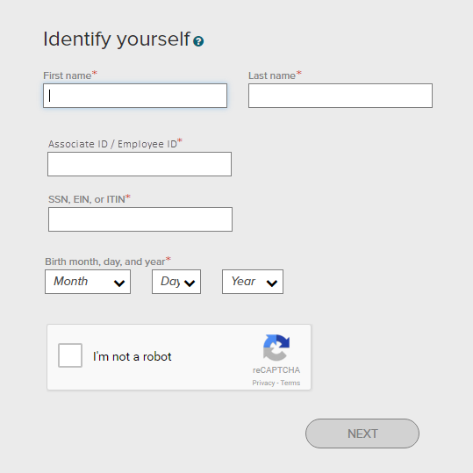

Complete the Google™ reCAPTCHA challenge.
This challenge is not required if you are registering with a personal registration code.
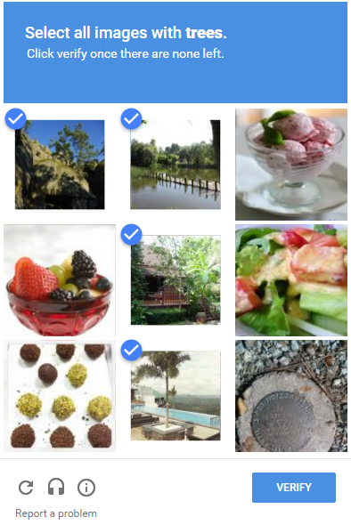
Sample Challenge
- Click on all the images that meet the required criteria.
- Select all responses that apply.

Need help?
- To get a new challenge, click the Refresh icon.
- To hear an audio challenge, click the Headphone icon.
- To learn more, click the Information icon.

Note: The appearance of the challenge might vary slightly based on your browser and its settings.
Complete the information required on this page to continue.
- Enter your contact information
To avoid answering your security questions during your next password reset, you can:
- Enter an email address and mobile phone number that are not shared with others.
- Authorize ADP to send you text messages about your account.
Note: ADP will send email or text messages about your account to the email address and mobile number you provide. For example, ADP can send you emails or text messages to help you retrieve your forgotten login information. ADP will also alert you if we suspect your account has been compromised.
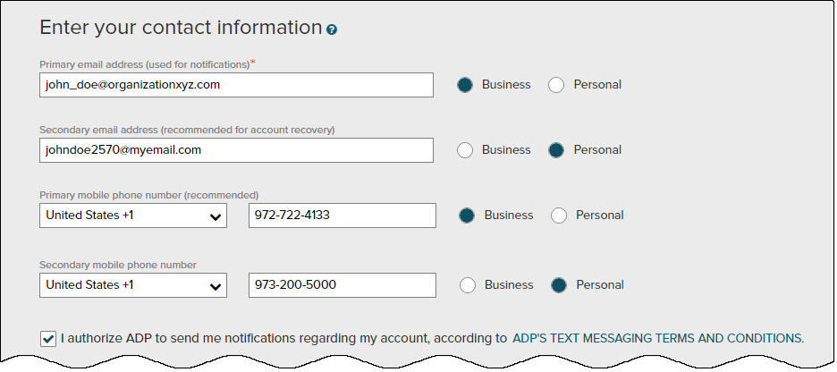
- View/Create your user ID and password
Memorize your user ID and password now, so you remember them later.
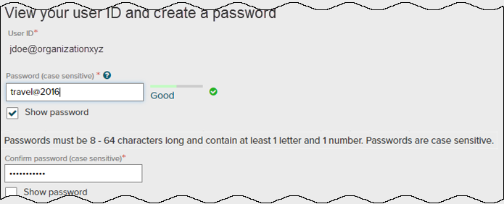
Depending on your organization’s setup, your user ID may be generated for you.

Depending on your organization’s setup, the option to create your user ID may be available.
- Select security questions and answers
To protect your account, the information you enter will be used to verify your identity if you forget your user ID and/or password. Answers are not case sensitive. Be sure to choose answers you can remember.
Use answers to your security questions that you can easily remember later.
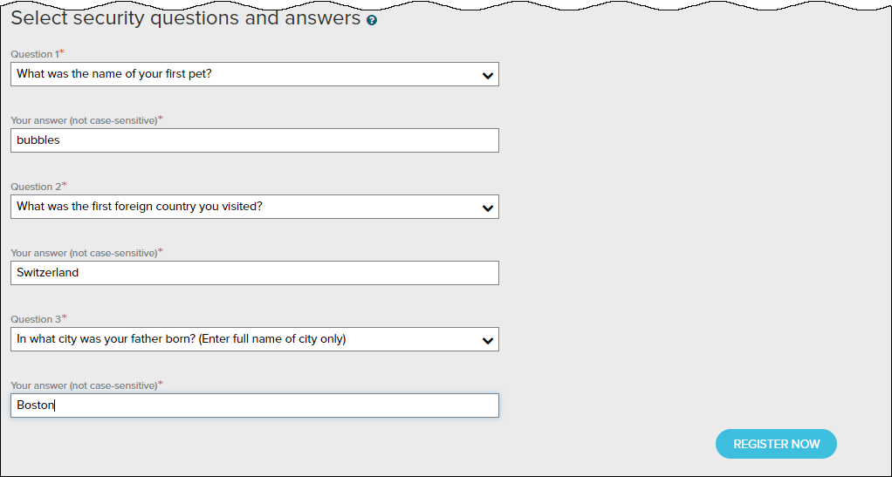
Click Register Now.
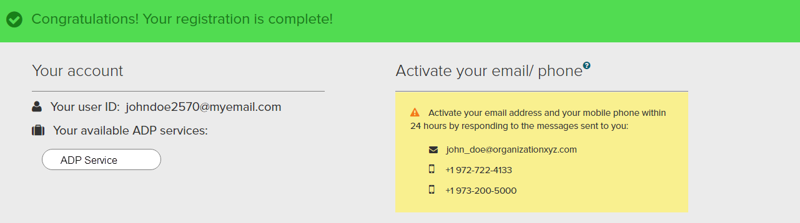
Your registration is complete. You can use your user ID and password to access your ADP service(s).
- Activate your email and mobile phone number to receive important notifications from your organization or ADP.
- Manage your account information to keep it accurate.

Activate Your Email Address
During registration, if you provided an email address that is not shared with others in your organization, look out for an activation email from ADP. Click the link in the email you receive from SecurityService_NoReply@ADP.com to complete the activation.
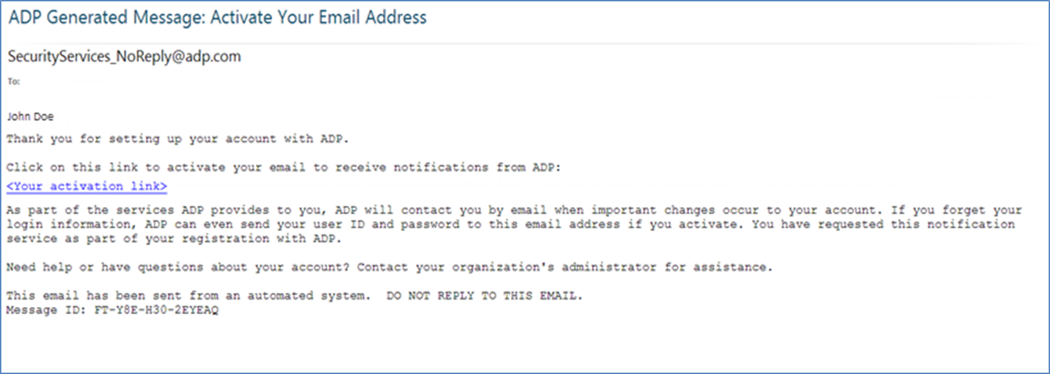

Activate Your Mobile Phone
During registration, if you provided a mobile phone number that is not shared with other users in your organization, look out for a text message from ADP. Reply with the code.
Note: In some countries, your activation process will differ; so, follow the instructions in the text message to activate your mobile number.

Forgot Your User ID/Password?
If you forget your login information, you can use the “Forgot Your User ID/Password?” link on your ADP service login page to retrieve your user ID and reset your password. During this process, you will be required to verify that you are the rightful owner of the account to protect your personal information.
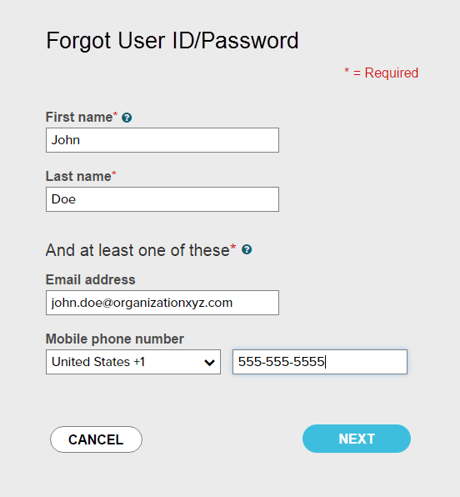
Enter your first name and last name exactly as they exist in your organization’s records.

Enter an email address and/or mobile phone number associated with your account.
Upon successful verification of the information that you entered, your user ID will be displayed.
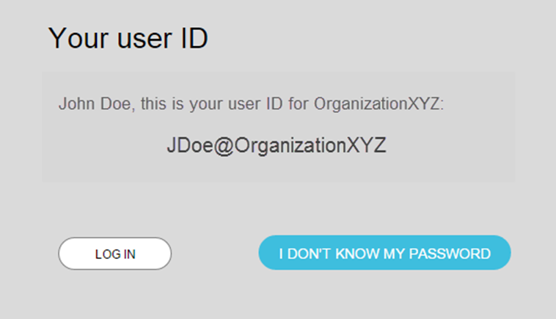
Click I DON’T KNOW MY PASSWORD to reset your account password.

The process will be different for administrators / practitioners.
Congratulations! You have successfully retrieved your user ID of your ADP service account.

To Reset Your Password
Select the “I don’t know my password” option. If you have an email address and/or mobile phone number that is not shared with others in your organization, you can receive and enter a security code.
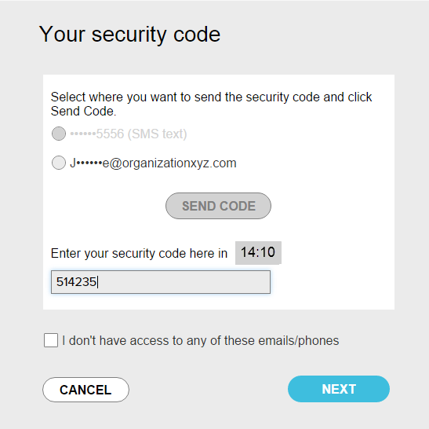
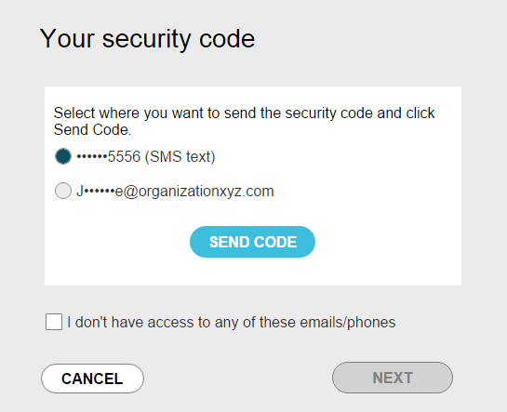
…and enter it here within 15 minutes.
Send the code to your email or mobile phone…
If you don’t have access to your email/phone or you share your email address and/or mobile phone number with others in your organization, you will be prompted to answer security questions instead.
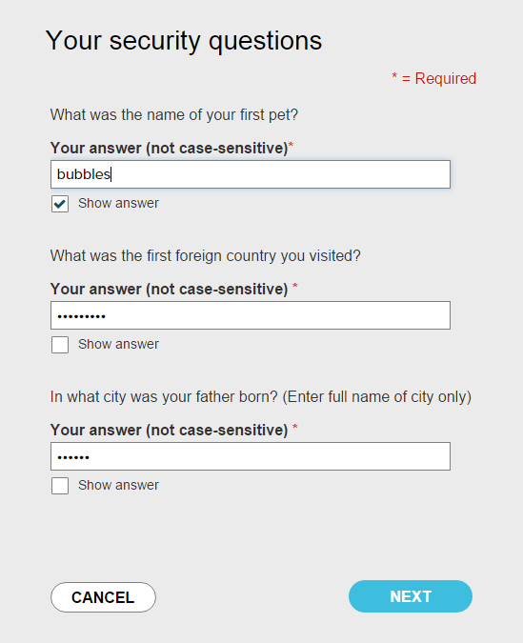
Click Show answer to reveal your answer briefly.
Upon successful verification of your security code or your security answers, you will be prompted to enter and confirm your new password.
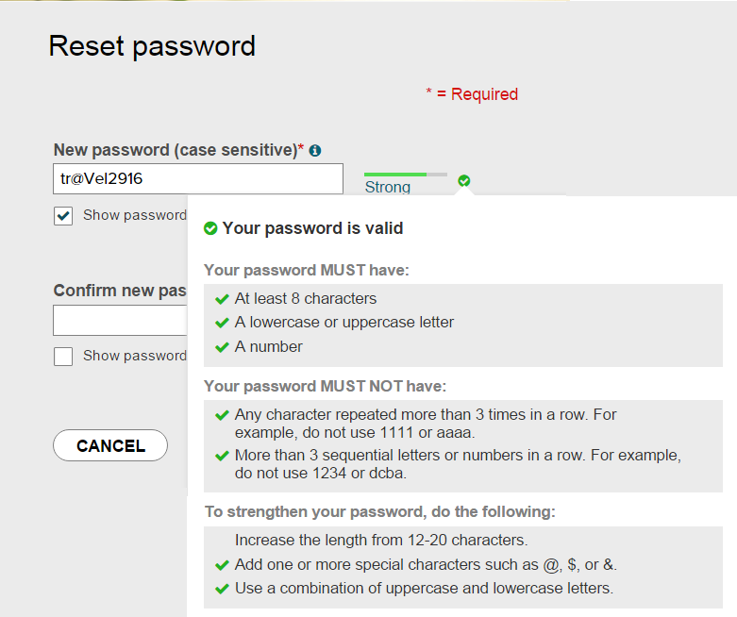
Click to see how well your password meets the requirements and how to make it stronger.
Click Show password to reveal your password briefly.
Congratulations! You have successfully retrieved your user ID and reset your password of your ADP service account.

