ADP Time and Attendance – Timecard instructions
To access the timecard log into ADP WorkforceNow Workforcenow.adp.com
Once in ADP, click on Myself, Time and Attendance, My Timecard. You will enter your total hours worked in the “hours” column. Please round time to the closest quarter hour.
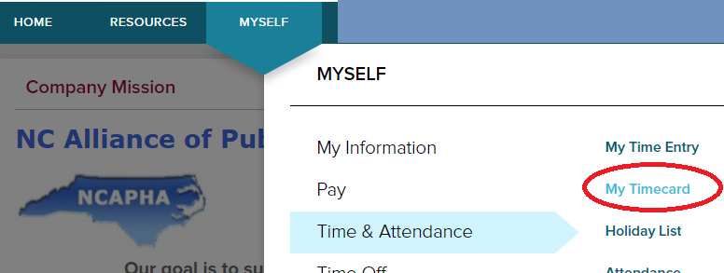

- Hours worked should be entered in the Hours column
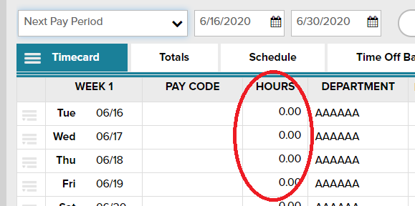
As an hours-based employee, enter the total number of hours you worked in the Hours column. You can record fractions of an hour by using up to two decimal places. Please round to the nearest quarter hour. For example, if you worked 4 hours and 15 minutes, type 4.25 in the Hours column.

- You can change the date displayed on the timecard by using the date selection drop down, or type in date range and click Find.
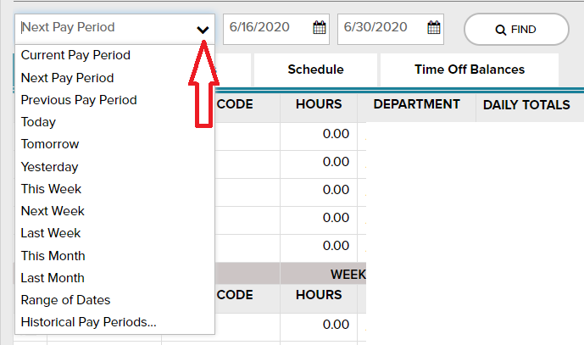

- Always remember to click “SAVE” at bottom left before exiting timecard
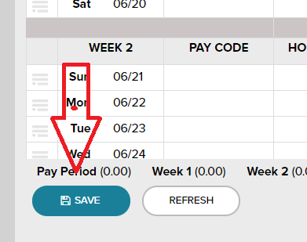
- Preferences should be set to 1 row per day 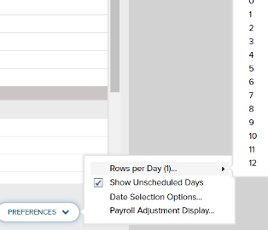

- To delete time from timecard: click to the left of the day to delete, select “delete from drop down menu, then click save.
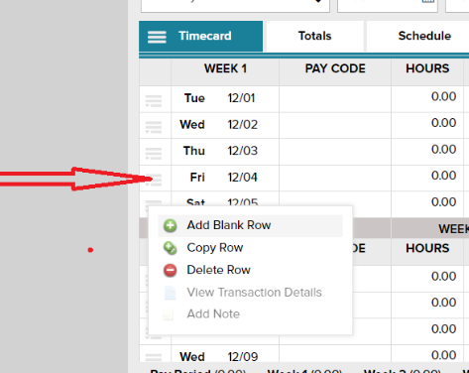

To watch a short tutorial, click the small teal square as shown below and then “My Timecard Learning Bytes”
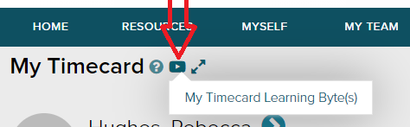
A new page will open, select “recording your total hours on your timecard”. A short video will demonstrate how to record and save your time.