To complete the Onboarding Paperwork, please read this in its entirety as it contains important information.
- Click on Edit and Submit
- Fill in the blanks.
  - You will notice that some forms have autofill on. Once you fill out one mandatory field, if it is needed throughout the form, it will auto populate.
For example on the Benefits Waiver for Assigned Employees:
- The word “Example” is where you should put the county that you are working in. Once you type it in the first box, the other boxes within the paragraph will autofill.
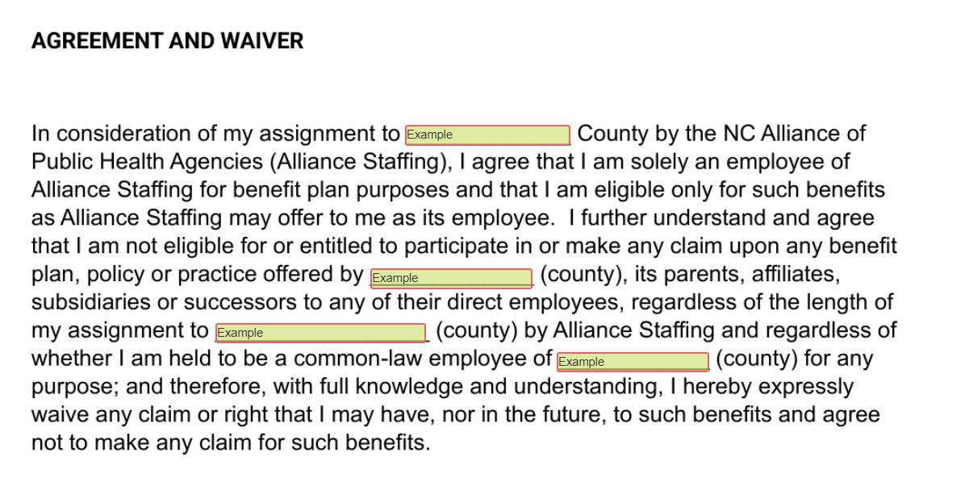
Click on Click here to sign document.
A prompt will pop up when you click to sign the document
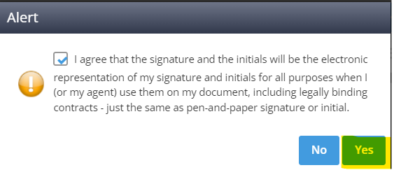
Click “Yes”
Enter todays date

Then up on the top are a left arrow, actions, and a right arrow.
**The left arrow will bring you back one field and the right arrow will bring you to the next field.**

Click the actions button.
Hit submit.
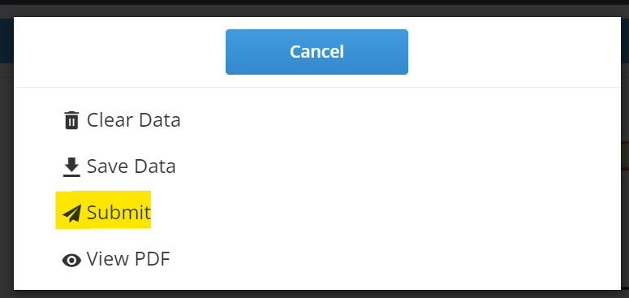
You will then be prompted that you are submitting the document:
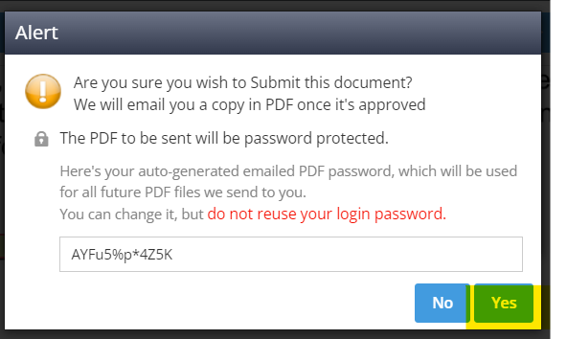
Click “Yes”
Once your have successfully submitted your document you will receive the following message:
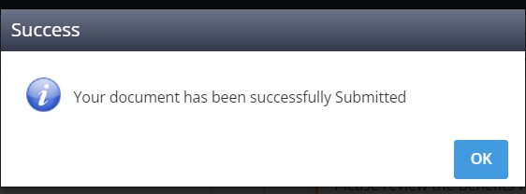

When moving to the other forms, you will receive this message:
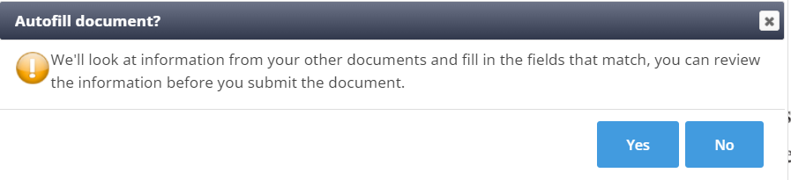
IMPORTANT INFORMATION!
****Please note that all fields in green with a red border are required. You will not be able to save these forms until all red fields have been filled in****

- All radio buttons that are in red are required.

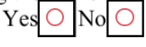

You will need to Submit the following forms even though you do not have to sign them:
- Payroll calendar
- OSHA Training instructions – if assigned to you

Once the forms have been submitted you will see either Approved or Submitted.
Approved means that the form does not need to be reviewed by Alliance Staff employee.
  - Emergency contact
  - OSHA Training instructions
Submitted forms will need to be reviewed by an Alliance Staff employee to ensure they are completed correctly:
- Benefits waiver
- Confidentiality Form
- Direct Deposit
  - I-9
  - NC4
- W4

Once an Alliance Staff employee has reviewed and deemed the forms to be complete, they will move to a completed status:
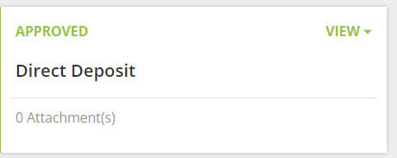
If any changes are deemed to be necessary, you receive an email like the one below:
The email will come from: hr@ncapha.org
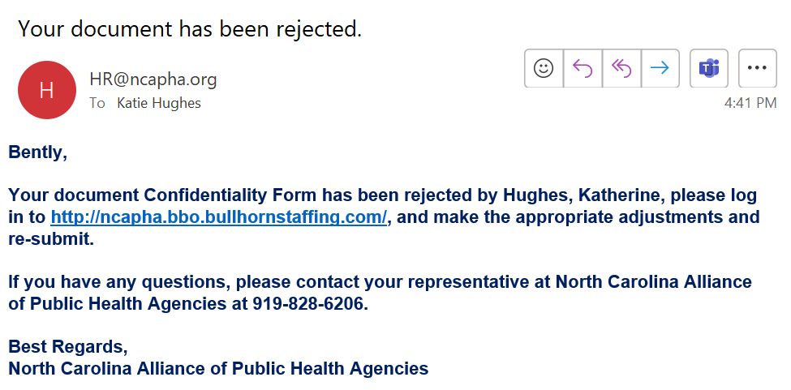

The form will them be back in “In Progress” status
