Instructions to apply online with upgraded ADP Work Force Now
Go to our website at: www.ncapha.org
Above Green “About Us” box see “Apply today”
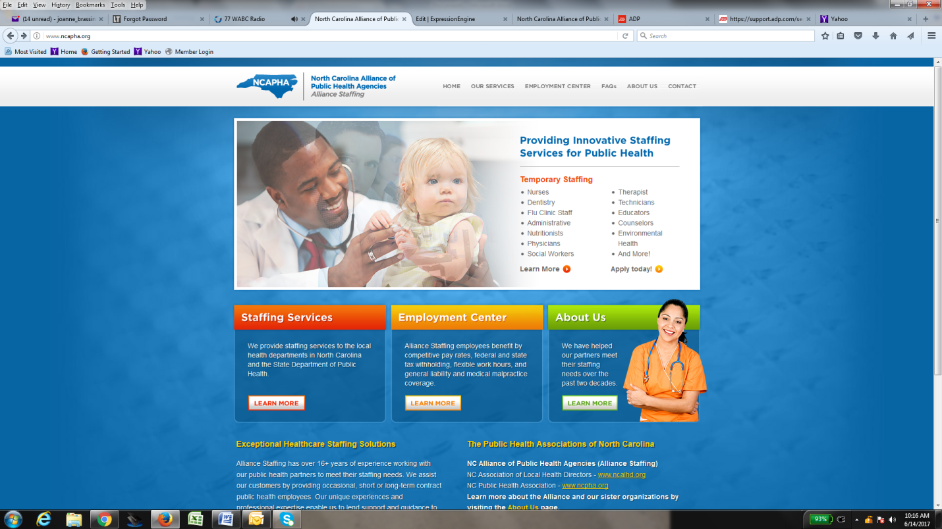
You will be directed to ADP Work Force Now (see example below)
1.) You’ll need to set up a Profile by selecting “apply” on upper right hand corner
You’ll set up security questions
3.)You’ll be re-directed to log in
4.) You’ll need to “apply

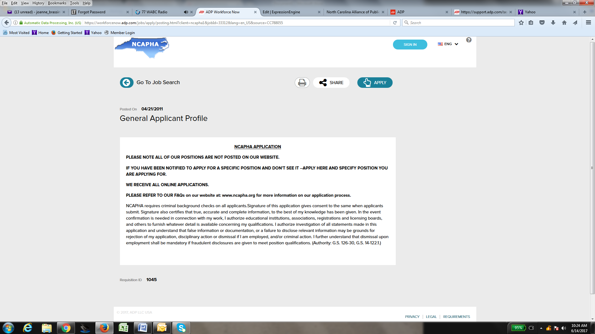
1.) You’ll need to set up a Profile by selecting “apply” on upper right hand corner

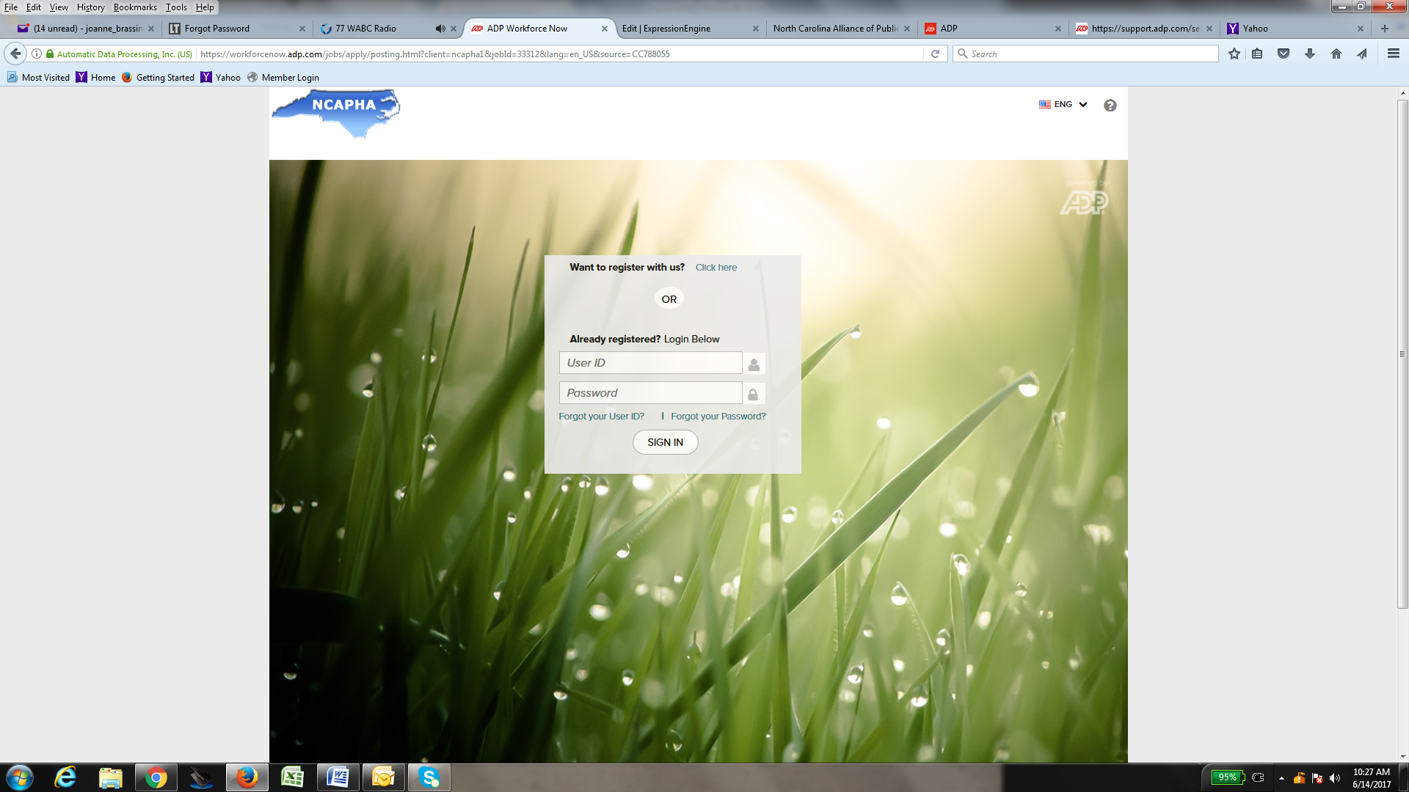
2.) You’ll need to set up a Register by selecting “Want to register with us?” select “click here”
A. Enter a User ID
B. Enter a Password
C. Select “sign in”

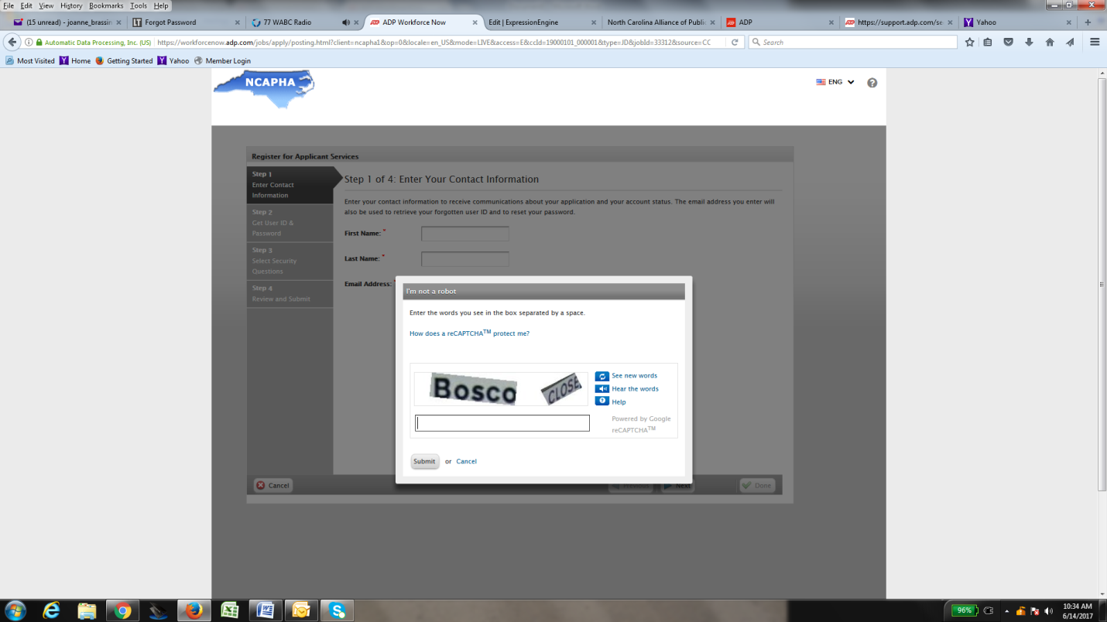
This is the initial page after setting up a profile –
You’ll need to proceed through 4 steps to register and apply including:
- Enter Contact Info
- Get User ID & password
- Select Security questions
- Review & submit

Step 1 – Enter Contact Info
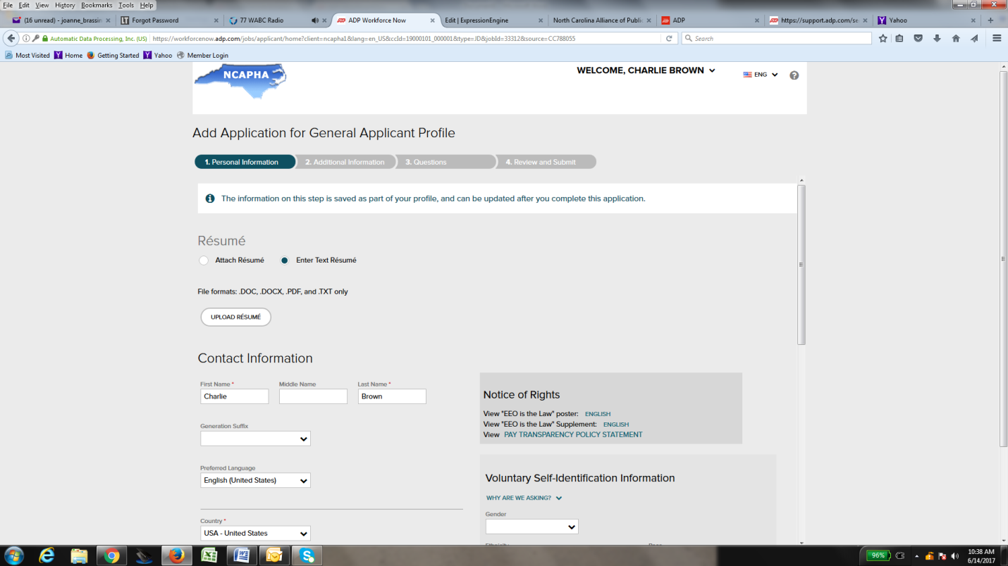
You will need to upload a resume or enter resume text (see below)

Résumé
Attach Résumé
Enter Text Résumé
File formats: .DOC, .DOCX, .PDF, and .TXT only

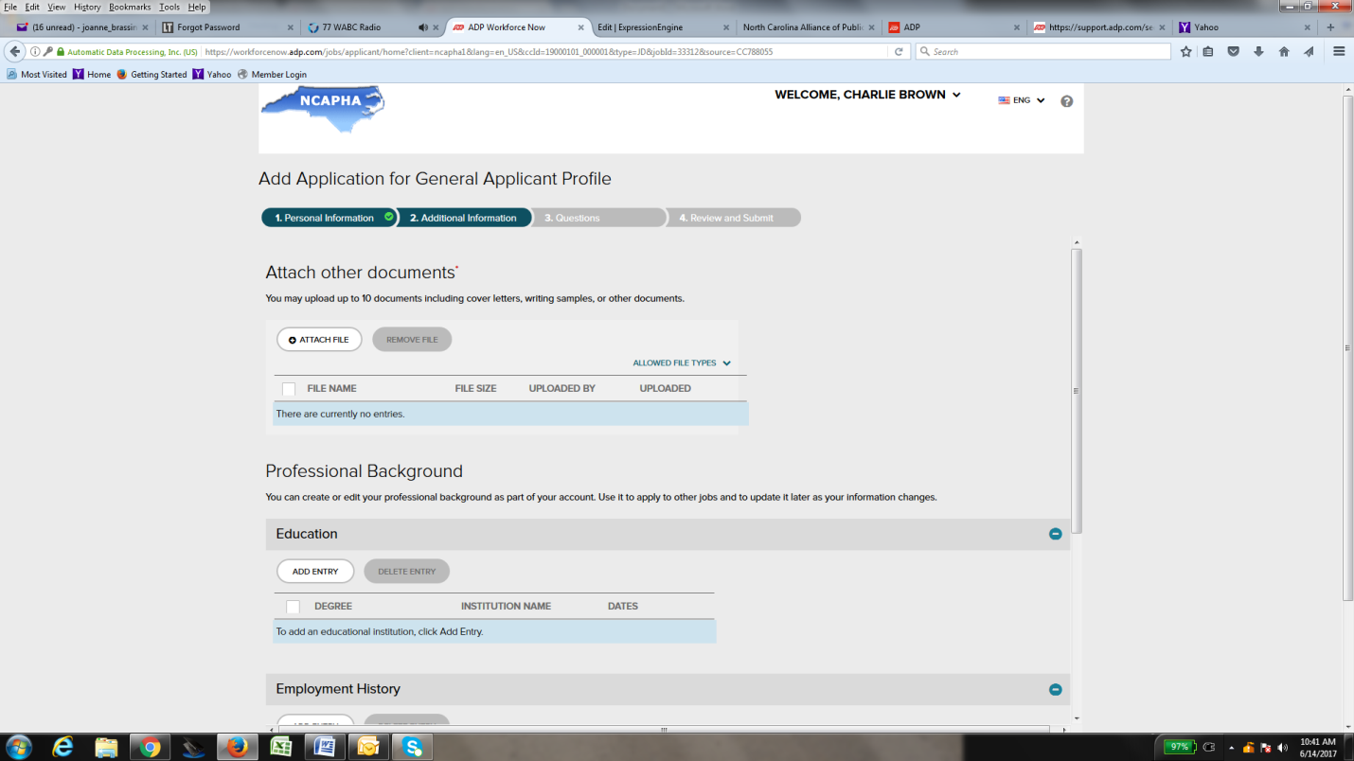
Step 2 – Additional Information
Applicants can add documents to their application such as: Cover letters.
ON THIS PAGE :
#1

Attach other documents | *
You may upload up to 10 documents including cover letters, writing samples, or other documents.

#2:

Professional Background
You can create or edit your professional background as part of your account. Use it to apply to other jobs and to update it later as your information changes.

To add an educational institution, click Add Entry.

Remainder of page applicants can enter information on the following 3 areas:

- Education 2.) Employment History 3.) Skills

Add Application for General Applicant Profile
This page is where the applicants answers questions for their online application:
STEP 3: QUESTIONS
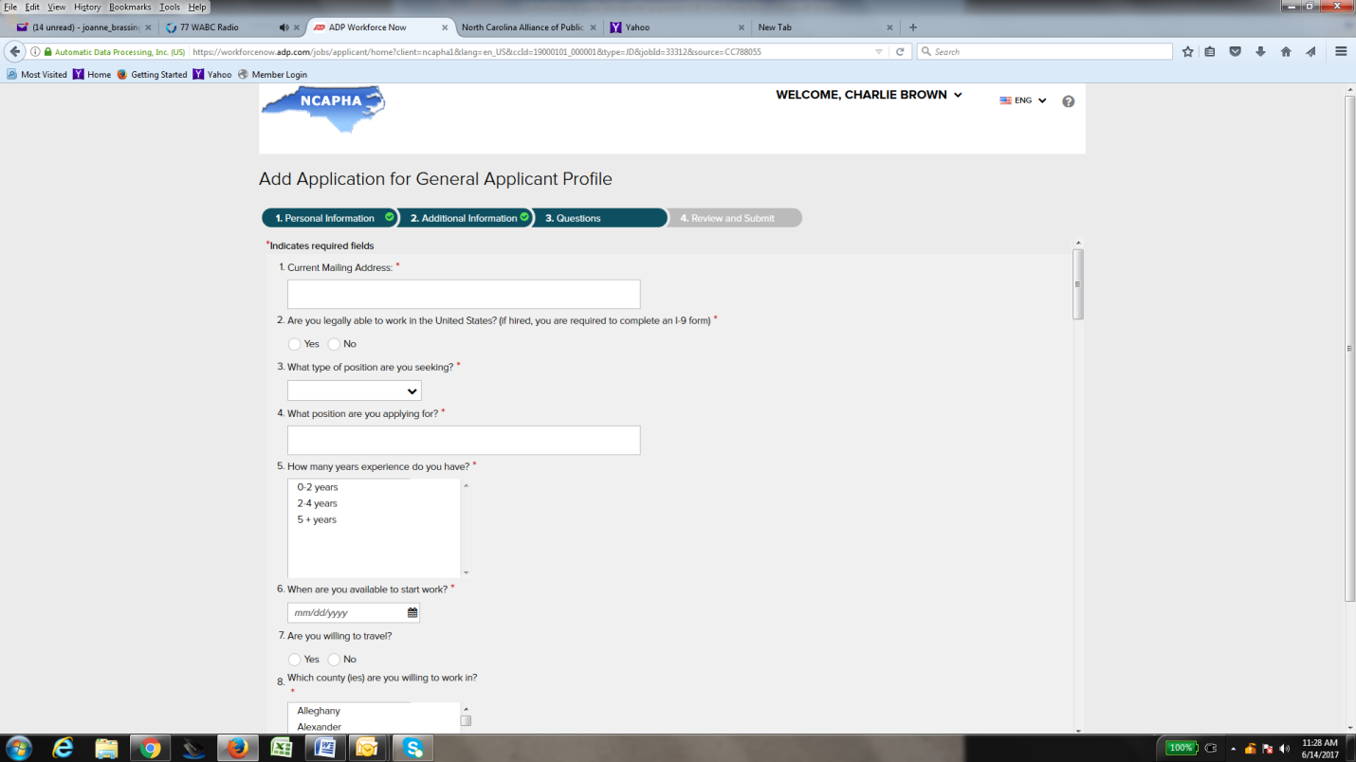
- Questions with an ** are required
- Once all questions have been answered, select “next”
- Will be directed to LAST PAGE of Online Application

STEP 4 – REVIEW AND SUBMIT
- Applicants can review all entered data and make necessary changes.
- After reviewing all information must hit “submit”

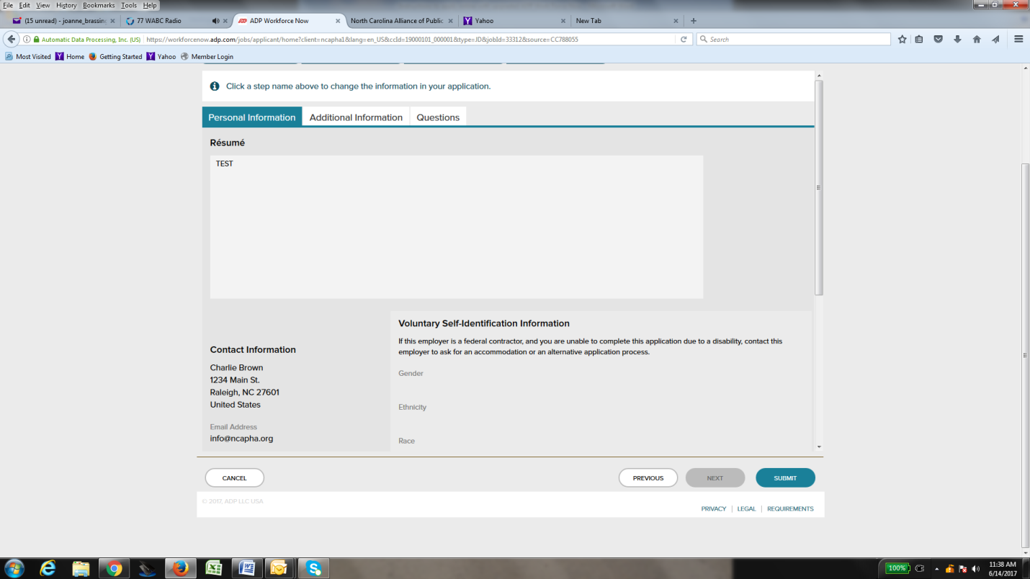

- After an applicant selects “submit” they’ll receive this message.
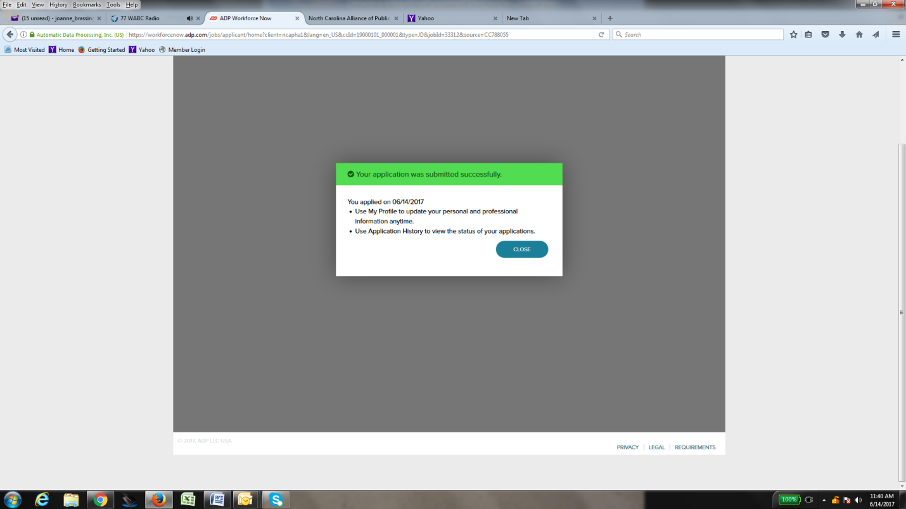
ONLINE APPLICATION IS COMPLETE!

***We’ve recently upgraded our HR system. Our vendor has recommended using the following browsers when submitting an online application: Google Chrome or Internet Explorer version 10 or higher. DO NOT use a cell phone or tablet to apply online only a computer.

